**Handout for Elastic Search Setup and Query**

**Made by Liyi Li**

1. Download elasticsearch 5.00, from the link:

<https://www.elastic.co/downloads/elasticsearch>

1. Download kibana

<https://www.elastic.co/downloads/kibana>

1. From kibana download x-pack (monitor and support plugin)

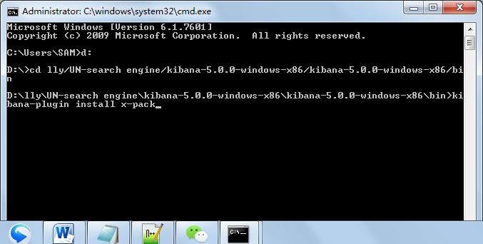

1. From elasticsearch 5.00 download x-pack

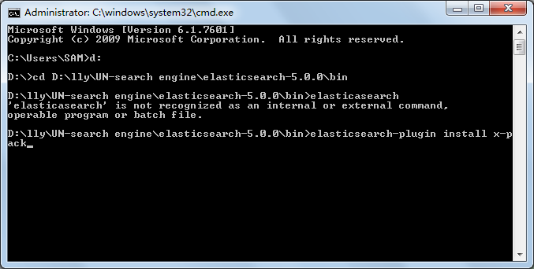

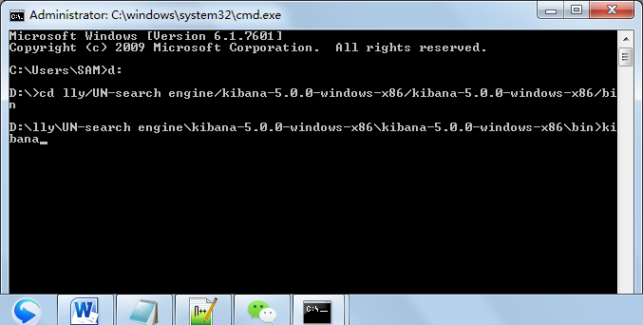

1. After run Elasticsearch, enter IE and type in localhost:9200, it can lead you to a user-surface: localhost:9200

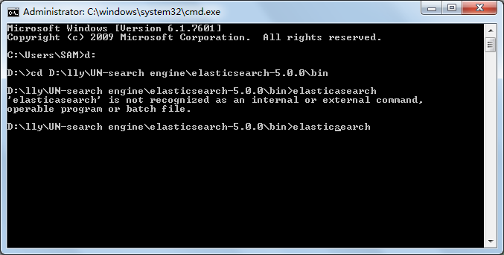

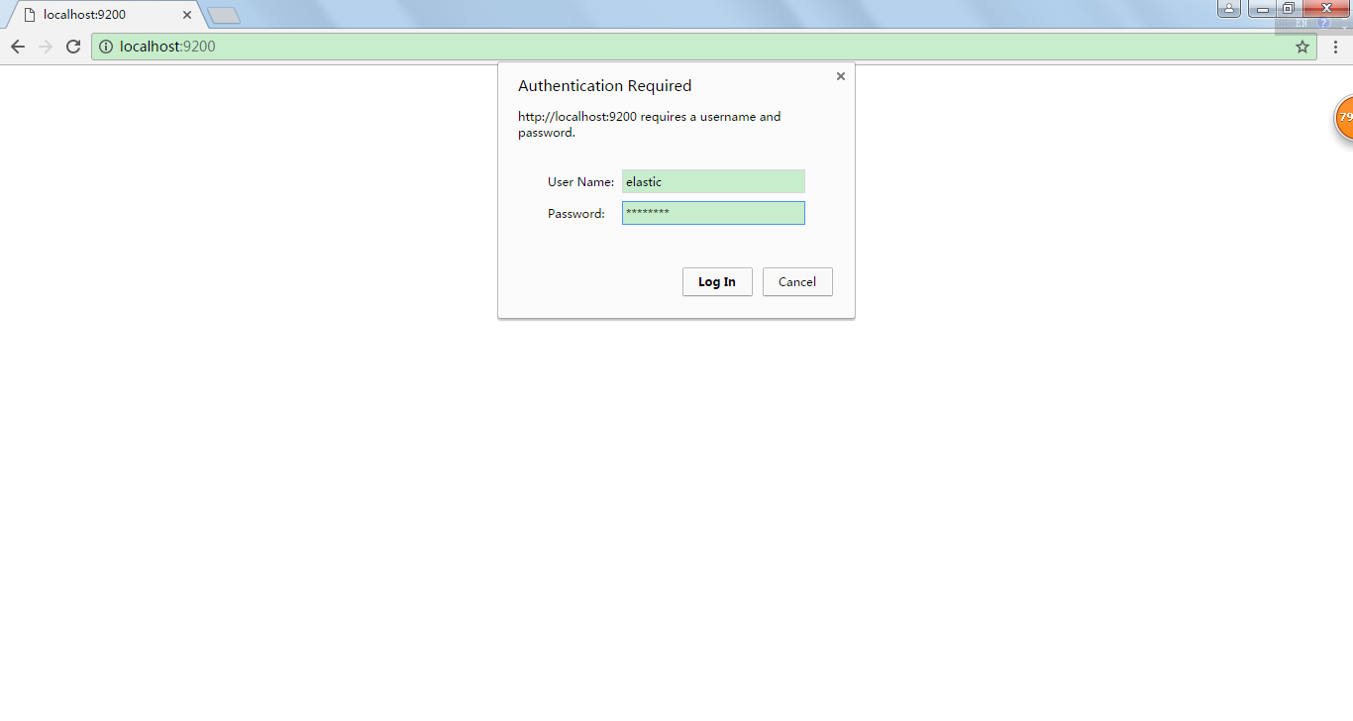

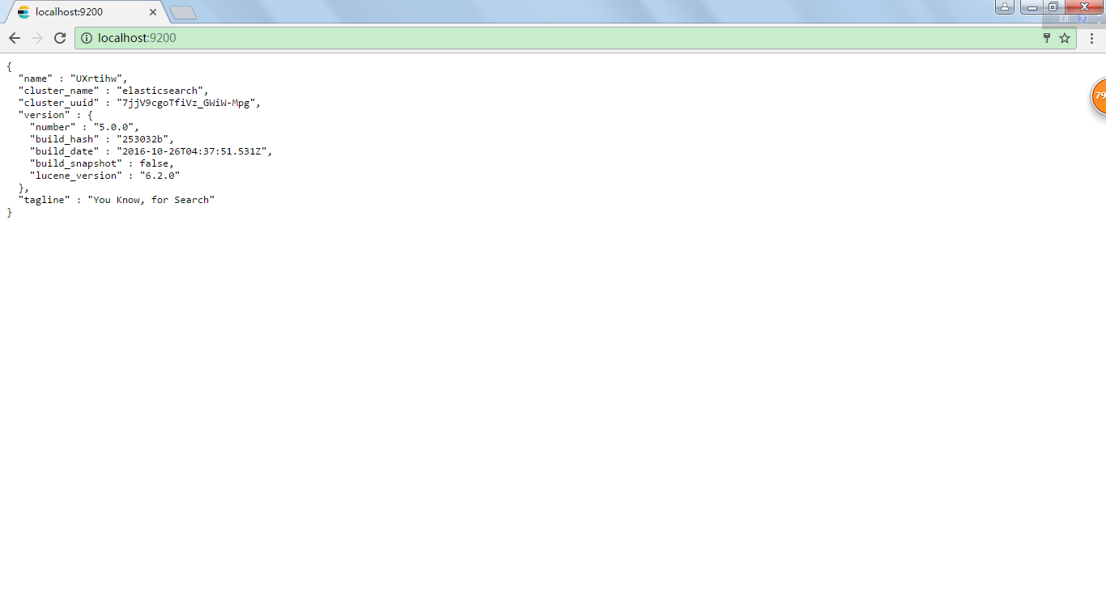

(Default username: elastic; Default password: changeme)

1. After run Kibana, open IE and type in localhost:5601, it will lead you to a user-surface: localhost:5601

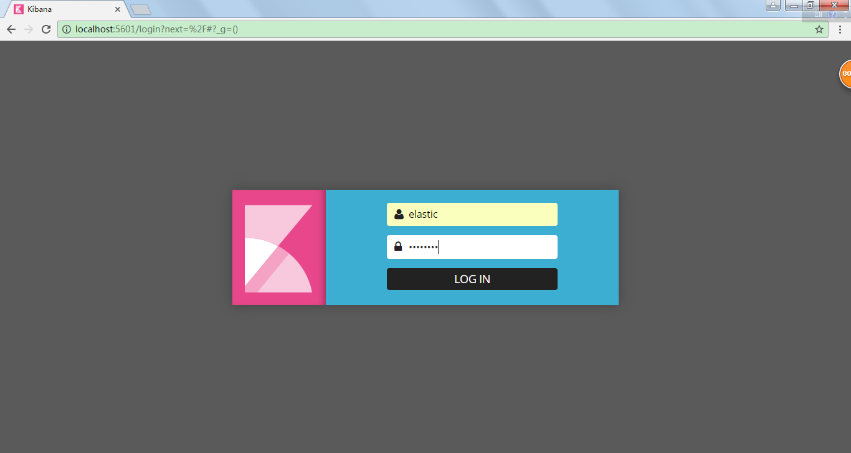

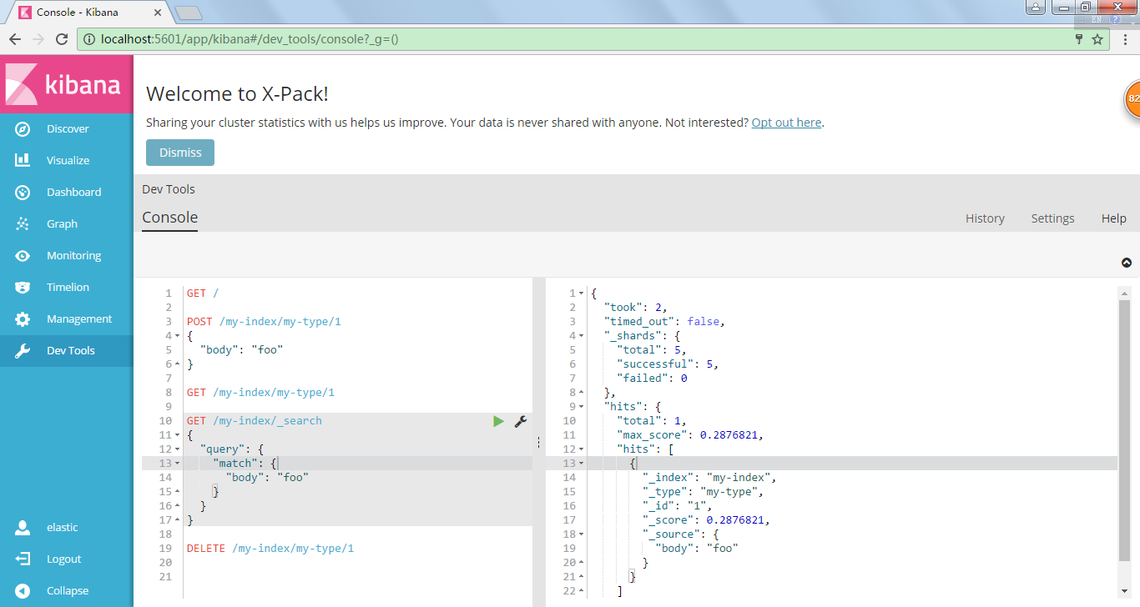

1. Do query on special rules, by curl commands:

<https://www.elastic.co/guide/en/elasticsearch/guide/current/_talking_to_elasticsearch.html>

curl -X<VERB> '<PROTOCOL>://<HOST>:<PORT>/<PATH>?<QUERY_STRING>' -d '<BODY>'

|  |  |
| --- | --- |
| VERB | The appropriate **HTTP *method* or *verb***: ***GET, POST, PUT, HEAD, or DELETE***. |
| PROTOCOL | Either http or https (if you have an https proxy in front of Elasticsearch.) |
| HOST | The hostname of any node in your Elasticsearch cluster, or localhost for a node on your local machine. |
| PORT | The port running the Elasticsearch HTTP service, which defaults to 9200. |
| PATH | **API Endpoint** (for example _count: will **return the number of documents in the cluster**). Path may contain multiple components, such as _cluster/stats or _nodes/stats/jvm |
| QUERY_STRING | Any optional query-string parameters (for example ?pretty will *pretty-print* the JSON response to make it easier to read.) |
| BODY | A JSON-encoded request body (if the request needs one.) |

1. simple query match in specific area
2. simple query match in specific area of phases
3. bool query must_not: not include: A&B
4. bool query must: include A&B at the same time
5. bool query should: A or B
6. bool query boost: give different combination part different weights, the higher the boost, the higher ranking for the documents containing specific queries
7. highlight fields in the original source
8. filter